For this assignment, you will choose to run one of the OTHERS InVEST models that we haven't yet run in class. You can use the InVEST sample data as your input. You will turn in a PDF/WordDoc that documents:

Scenic Quality

Yuheng Du

1. What model you ran and the general concept of why this ecosystem service is valuable to humans

[Scenic Quality — InVEST® documentation (naturalcapitalproject.org)](http://releases.naturalcapitalproject.org/invest-userguide/latest/en/scenic_quality.html)

Environmental issues are increasingly occupying a significant weight in people's daily research and discussions. Human activities are exacerbating their impact on coastal ecosystems, which could damage the unique landscape quality associated with coastal and marine areas. Coastlines and their "seascapes" are important economic assets, attracting tourists for travel and recreation, and enhancing the quality of life for those living near the coast. Development projects near and offshore often spark concern in local communities that value natural seascapes. Visual impacts, as external effects, if not quantified and accounted for, cannot be considered in assessing the costs and benefits of new coastal developments. From site selection for aquaculture facilities to reduce spatial competition with tourism activities (Perez 2003) to visibility assessments of coastal lines and seascapes for offshore wind projects (Environmental Design and Research 2006), viewshed analysis is widely applied. Given the crucial importance of scenic beauty to residents and tourists near the coast, coastal planners can incorporate measures of visual accessibility or inconvenience into broader policy discussions and planning activities. Although most applications of viewshed analysis focus on the negative impacts of new facilities, the expressions in the InVEST Landscape Quality Model assume that the observed objects negatively affect the landscape. However, positive interpretations of these objects can also be incorporated into the model results.

The viewshed maps generated by this model can identify coastal areas most likely to be directly impacted by enhanced landscapes. These viewshed maps can serve as important inputs for a broader analysis of the range of services provided by marine environments. The model can be used to calculate the costs arising from visual impacts offshore, which may decrease as facility locations move further from shore, while the installation and operational costs of offshore facilities typically increase with distance from the coastline. Although only a few studies have explored the economic impact of visual inconvenience caused by offshore development projects, one recent study showed that the external costs to coastal residents from visual inconvenience due to offshore wind projects ranged from $27 to $80 (Krueger et al. 2010). In contrast, research by Firestone et al. (2009) found that public acceptance of offshore renewable energy projects is increasing and may not be as controversial as previously anticipated.

Therefore, beautiful coastal and marine landscapes contribute to the welfare of local communities in various ways. These scenic areas support local business activities by attracting tourists, thus playing an important role in enhancing the local economy. The value of local real estate depends to some extent on its geographic location, and beautiful landscapes can often enhance the market value of local properties (Sanders and Polasky 2009, Bourassa et al. 2004, Benson et al. 2004). Local communities and their residents often have a deep affection for landscapes and strongly oppose new development projects that may destroy existing landscapes and reduce the benefits derived from them (Ladenburg and Dubgaard 2009, Haggett 2011).

2. A brief description of the key calculations to be done

Scenic Quality model, which computes the visual impact of features in a landscape.

For each structure site (feature X): Calculate the visibility for each point feature X using a viewshed algorithm, resulting in ‘ visibility_X. tif’. Determine the value of the visibility amenity/disenamenity by applying a valuation function to the visibility, resulting in ‘ intermediate_value_X.tif’.

Aggregate the outputs: Sum the valuation rasters from all features to create a weighted aggregate (‘vshed_value.tif’). Divide the weighted, aggregate valuation raster into quartiles to create a raster representing visual quality (‘vshed_qual.tif‘) . Weight and sum the visibility raster from all structure points to create a weighted sum of visible points (‘vshed.tif’)

The model offers three valuation function forms:

Linear: f(x)=a+bx

Logarithmic: f(x)=a+b*ln(x)

Exponential: f(x)=a*e^(-bx)

3. A briefer description of each data input

Specific steps:

Preparing Input Data: we will need to have all the GIS data prepared and organized within a specific workspace directory. This includes: An Area of Interest (AOI), which is likely represented by the files `AOI_WCVI.*`. Features that impact scenic quality, which are probably contained in the `AquaWEM_points.*` files. And A Digital Elevation Model (DEM) to provide the landscape's elevation data, found in the file `claybark_dem.tif`.

Configuring the Model: With workspace established, the next step is to configure the InVEST Scenic Quality model using the input files. The model will execute several steps: Calculate the visibility of each feature in the landscape (`visibility_X.tif`). Assess the visual impact of each feature based on visibility and distance (`value_X.tif`). Aggregate the data to provide a comprehensive overview of the visual quality of the landscape (`vshed_value.tif`, `vshed_qual.tif`). Additionally, apply weightings to each feature's viewshed if necessary, which will influence the overall visual impact assessment.

We have the option to select between different valuation functions (linear, logarithmic, or exponential) that will be used to calculate the visual impact of each feature. The choice of function and the coefficients (A and B) will affect how the model interprets the data.

There are also some additional Parameters: The `radius`, `weight`, and `height` parameters can be optionally defined for each feature to refine the visibility analysis. The refractivity coefficient is also required to adjust for the Earth's curvature and atmospheric refraction.

Summarize InVest:

1. General Inputs:

Workspace: This is a mandatory directory path where all the output files from the model's execution will be saved.

File Suffix: An optional text field to append a suffix to all output file names for differentiation.

Area of Interest: A required input in the form of a vector polygon/multipolygon that defines the geographic area over which the model will summarize the final results.

Features Impacting Scenic Quality: A required vector point input that maps the locations of objects negatively affecting scenic quality, such as aquaculture net pens or wave energy facilities.

2. Fields for Each Feature:

Radius: An optional numeric field specifying the maximum line of sight length from a viewpoint.

Weight: An optional numeric field to apply weights to the visibility of each feature.

Height: An optional numeric field indicating the elevation of a viewpoint above the ground for each feature.

3. Additional Model Inputs:

Digital Elevation Model: A required raster input that maps elevation above sea level, crucial for visibility analysis.

Refractivity Coefficient: A required ratio that adjusts for the Earth's curvature and refraction of light in the visibility analysis.

4. Valuation Process:

Run Valuation: A true/false field to decide whether to run the valuation model.

Valuation Function: A conditionally required option field to select the mathematical function for valuation (exponential, linear, or logarithmic).

Coefficient A & B: Conditionally required numeric fields representing the coefficients for the selected valuation function.

Maximum Valuation Radius: An optional numeric field indicating the radius within which the valuation is computed for each cell.

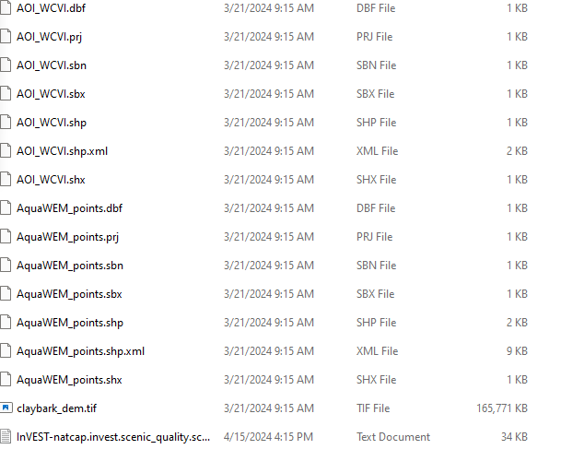

This figure shows the input data of the scenic quality,

.dbf: Database file that stores attributes data in a tabular format for use in GIS applications. Each row corresponds to a feature (like a point, line, or polygon), and each column contains a particular piece of information about that feature.

.prj: Projection file that stores the metadata describing the coordinate system and projection information used by the shapefile.

.sbn and .sbx: Spatial index files that store the index of the feature geometry, allowing for quicker spatial searching.

.shp: Shapefile that stores the feature geometry itself. This is the main file that contains the data for points, lines, or polygons.

.shx: Shape index file that acts as a positional index of the feature geometry to facilitate searching and accessing the geometric data in the .shp file more quickly.

.xml: Metadata file that contains information about the shapefile's data and structure.

.tif: TIFF (Tagged Image File Format) that in the context of GIS is often used as a raster file for storing elevation data or images such as satellite imagery or aerial photography.

4. Image(s) of your result. Refer to the InVEST users' guide to see which output layers are actually the interesting outputs and how you should interpret them.

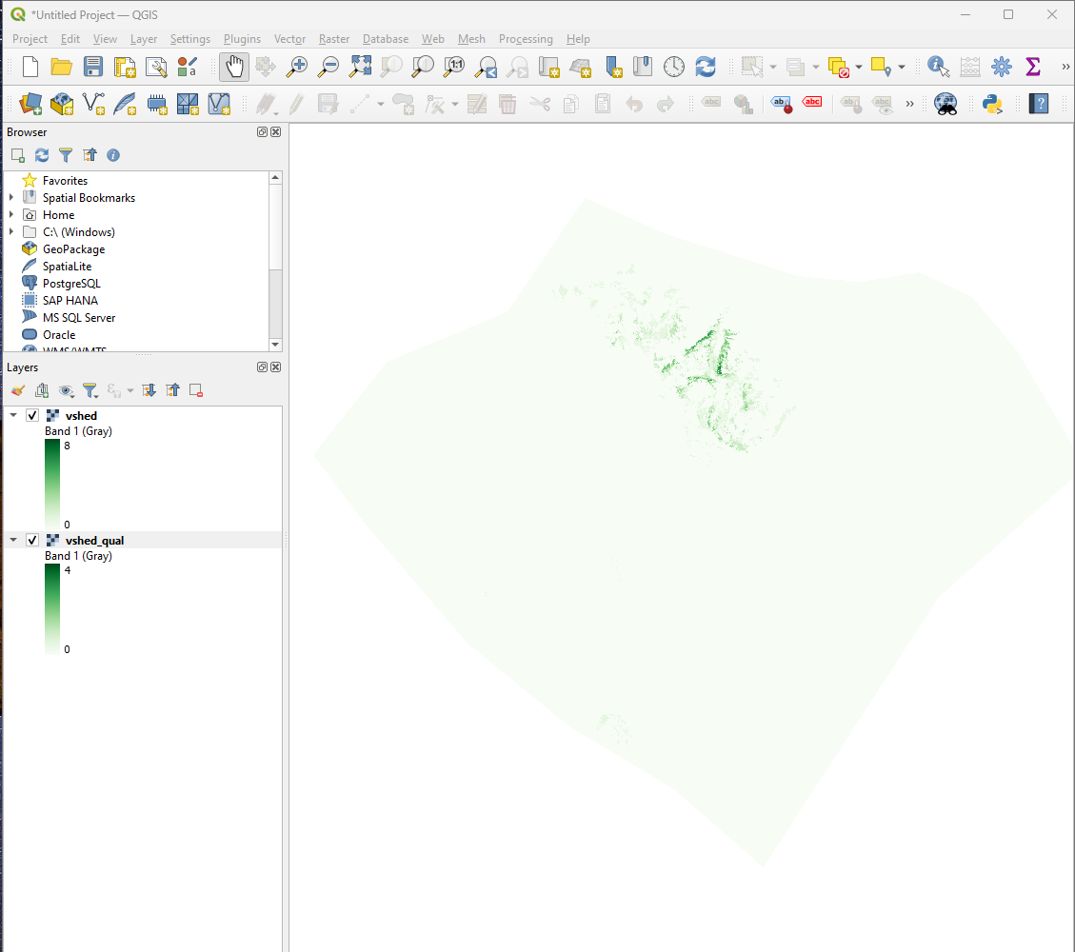

The result of vshed. This layer illustrates the weighted sum of all visibility rasters. It gives us the count of the number of structure points that are visible from each pixel. When no weight column is provided in the structures point vector, the output defaults to this count. The `vshed` layer in QGIS appears to represent the distribution of these visibility counts across AOI. We can use this layer for scenario comparison. By calculating the difference between `vshed` outputs from multiple runs, we can assess changes in visual quality across scenarios. This is the preferred layer as it allows for quantitative analysis of changes in visibility.

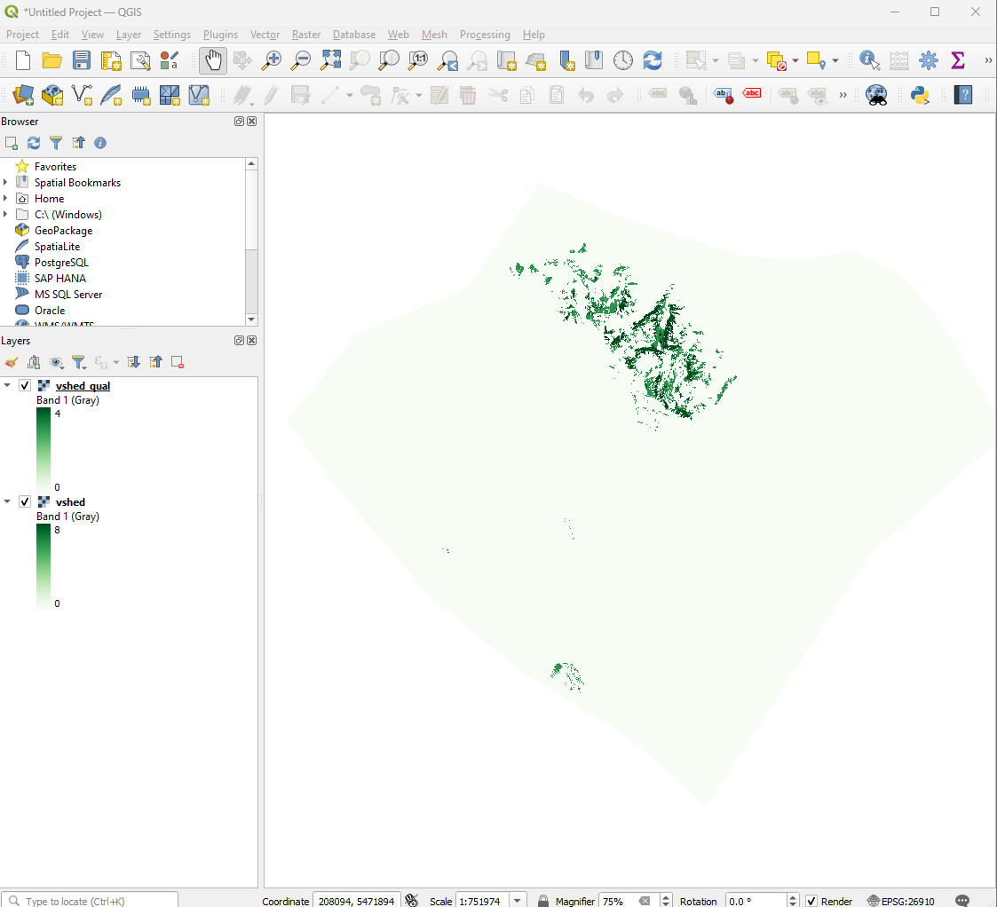

The result of vshed_qual. This output file provides a classification of visual quality within the Area of Interest (AOI). The classifications are based on quartiles and signify varying levels of visual impact:

- Unaffected (no visual impact)

- High (low visual impact)

- Medium (moderate visual impact)

- Low (high visual impact)

- Very low (very high visual impact)

the `vshed_qual` layer shows these classifications. Darker areas typically represent higher visual quality, whereas lighter areas correspond to lower visual quality.

5. A sensitivity analysis of at least 1 variable (of your choosing) where you will iteratively run in Python (include your script as an appendix) InVEST for at least 10 values of the variable. Create a graph of how the output(s) for your ES change over the range of parameters.

This figure shows the relationship between the 'refraction' parameter and the mean visual quality output of the InVEST Scenic Quality model. This sensitivity analysis demonstrates how the variable 'refraction' impacts the output of the model across a range of values from 0.05 to 0.5. The plot has a clear upward trend, indicating that as the 'refraction' value increases, the mean visual quality also increases. I ran the InVEST Scenic Quality model using a Python script, altering the 'refraction' parameter for each run. The parameter was adjusted over 10 different values, linearly spaced between 0.05 and 0.5. After each model execution, the output TIFF file named "vshed_qual.tif" was read using rasterio to calculate the mean visual quality score, which ignores any NoData values. The analysis indicates that 'refraction' is a significant factor affecting the scenic quality outputs, with higher 'refraction' values yielding higher mean visual quality scores. This finding could imply that areas with greater atmospheric refraction may be perceived as having better scenic quality, or that the model attributes higher visual quality to views that are affected by stronger refraction phenomena.

Appendix:

# coding=UTF-8

# -----------------------------------------------

# Generated by InVEST 3.14.1 on Mon Apr 15 22:58:05 2024

# Model: Scenic Quality

import logging

import sys

import rasterio

import numpy as np

import pandas as pd

import matplotlib.pyplot as plt

import natcap.invest.scenic_quality.scenic_quality

import natcap.invest.utils

import logging

import sys

import natcap.invest.scenic_quality.scenic_quality

import natcap.invest.utils

LOGGER = logging.getLogger(__name__)

root_logger = logging.getLogger()

handler = logging.StreamHandler(sys.stdout)

formatter = logging.Formatter(

    fmt=natcap.invest.utils.LOG_FMT,

    datefmt='%m/%d/%Y %H:%M:%S ')

handler.setFormatter(formatter)

logging.basicConfig(level=logging.INFO, handlers=[handler])

args = {

    'a_coef': '',

    'aoi_path': 'C:\\Users\\dyyan\\OneDrive\\Desktop\\base_data\\invest_sample_data\\ScenicQuality\\Input\\AOI_WCVI.shp',

    'b_coef': '',

    'dem_path': 'C:\\Users\\dyyan\\OneDrive\\Desktop\\base_data\\invest_sample_data\\ScenicQuality\\Input\\claybark_dem.tif',

    'do_valuation': False,

    'max_valuation_radius': '',

    'refraction': '0.1',

    'results_suffix': '',

    'structure_path': 'C:\\Users\\dyyan\\OneDrive\\Desktop\\base_data\\invest_sample_data\\ScenicQuality\\Input\\AquaWEM_points.shp',

    'valuation_function': 'linear',

    'workspace_dir': 'C:\\Users\\dyyan\\OneDrive\\Desktop\\base_data\\invest_sample_data\\ScenicQuality\\Input',

}

if __name__ == '__main__':

    natcap.invest.scenic_quality.scenic_quality.execute(args)

# Define the function to read the output TIFF file

def read_model_output(output_path):

    with rasterio.open(output_path) as src:

        return np.nanmean(src.read(1))  # Read the first band and calculate the mean, ignoring NaNs

# Perform sensitivity analysis on 'refraction'

refraction_values = [0.05 * i for i in range(1, 11)]  # Range of refraction values from 0.05 to 0.5

results = []

for refraction in refraction_values:

    args['refraction'] = refraction

    LOGGER.info(f"Running model with refraction: {refraction}")

    natcap.invest.scenic_quality.scenic_quality.execute(args)

    # Construct the path to the output TIFF file

    output_path = f"{args['workspace_dir']}\\output\\vshed_qual.tif"

    # Read the output

    output = read_model_output(output_path)

    results.append(output)

# Store results in a DataFrame and plot

df = pd.DataFrame({

    'Refraction': refraction_values,

    'VisualQualityMean': results

})

plt.figure(figsize=(10, 6))

plt.plot(df['Refraction'], df['VisualQualityMean'], marker='o')

plt.title('Sensitivity Analysis of Refraction on Scenic Quality Output')

plt.xlabel('Refraction')

plt.ylabel('Mean Visual Quality')

plt.grid(True)

plt.savefig('sensitivity_analysis.png')

plt.show()